Day29&30 - Task13 - AWS CloudFront & Route53

Task: 1 Purchase one domain from GoDaddy.

To purchase and register a new domain name using GoDaddy, enabling it to be used for websites, email, or cloud services.

Step 1: Open the GoDaddy Website
- Launch your web browser.
- Open the GoDaddy website using the link below:
GoDaddy Official Website

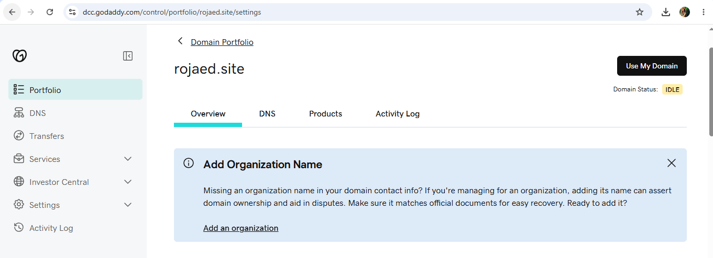

Task: 2. Deploy static website in S3.

To create an Amazon S3 bucket, upload static website files (HTML), enable Static Website Hosting, configure public access, and deploy a static website accessible over the internet.

Step 1: Open Amazon S3
- In the AWS Console search bar, type S3.
- Select Amazon S3.
- Click Create Bucket.
Step 2: Create an S3 Bucket

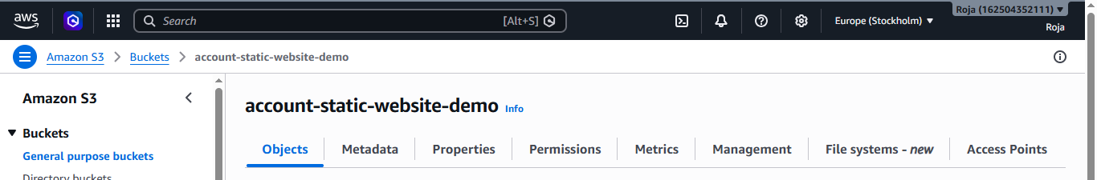

Step 3: Upload Website Files
- Open the newly created bucket.
- Click Upload.
- Click Add Files
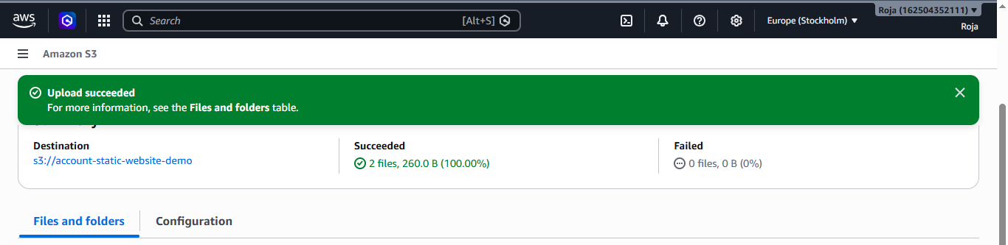
Step 4: Enable Static Website Hosting
- Open the bucket.
- Select the Properties tab.
- Scroll to Static Website Hosting.
- Click Edit
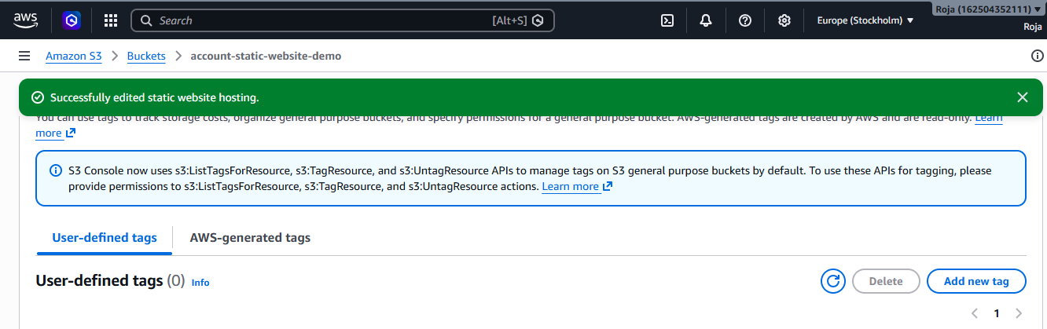
Step 5: Make public using ACL for both the files:
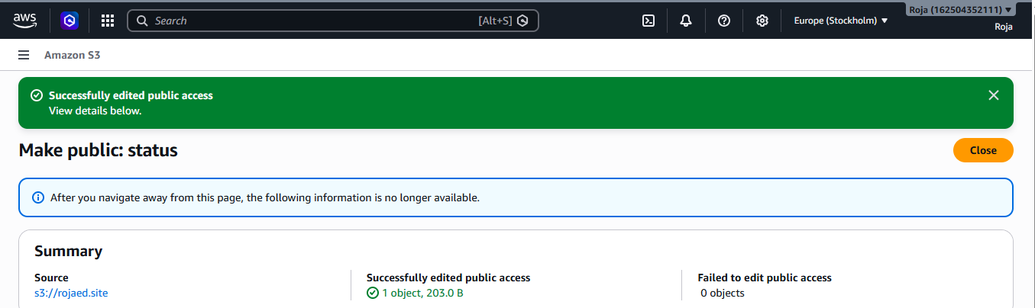
Step 6: Configure Bucket Policy
- Select the Permissions tab.
- Scroll to Bucket Policy.
- Click Edit.
- Paste the following policy (replace the bucket name with your own):
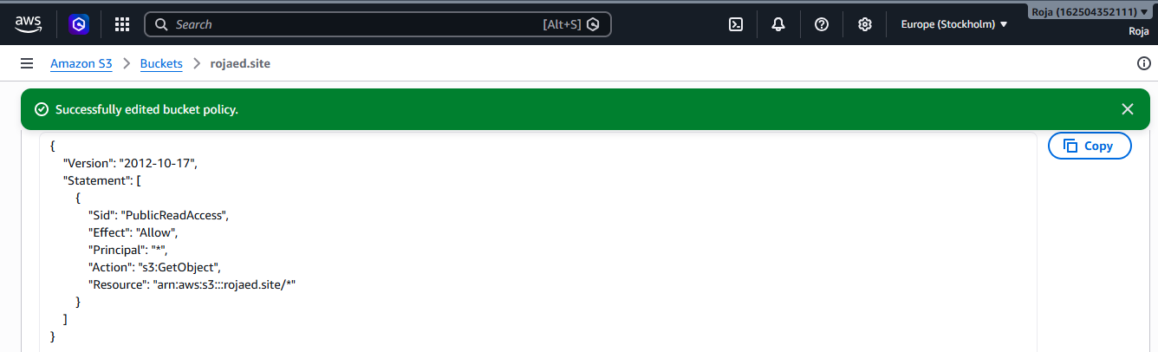
Step 7: Verify Object Permissions
- Open the Objects tab.
- Select index.html.
- Copy the Object URL.
- Open it in a browser to verify that the file is publicly accessible.
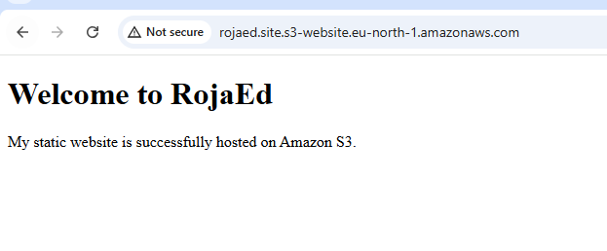
Step 8: Access the Static Website
- Return to the Properties tab.
- Scroll to Static Website Hosting.
- Copy the Bucket Website Endpoint.
- Open the endpoint in a web browser.
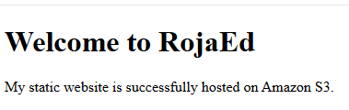

Task: 3.Create a CDN and attach one SSL certificate.

Objective

To create an Amazon CloudFront distribution for a static website hosted in Amazon S3 and secure it with an SSL/TLS certificate issued by AWS Certificate Manager (ACM), enabling HTTPS access through a custom domain.

Prerequisites
- AWS Account
- A registered domain name (for example, example.com)
- Amazon S3 bucket configured for Static Website Hosting
- Static website uploaded to the S3 bucket
- Domain DNS managed through your registrar or Amazon Route 53
- Permissions to create ACM certificates and CloudFront distributions

Step 1: Open AWS Certificate Manager (ACM)
- Sign in to the AWS Management Console.
- Change the AWS Region to US East (N. Virginia) – us-east-1.
- Note: CloudFront uses ACM certificates that are created in us-east-1.
- Search for Certificate Manager.
- Open AWS Certificate Manager (ACM).
Step 2: Request a certificate in ACM in North Virginia us-east-1
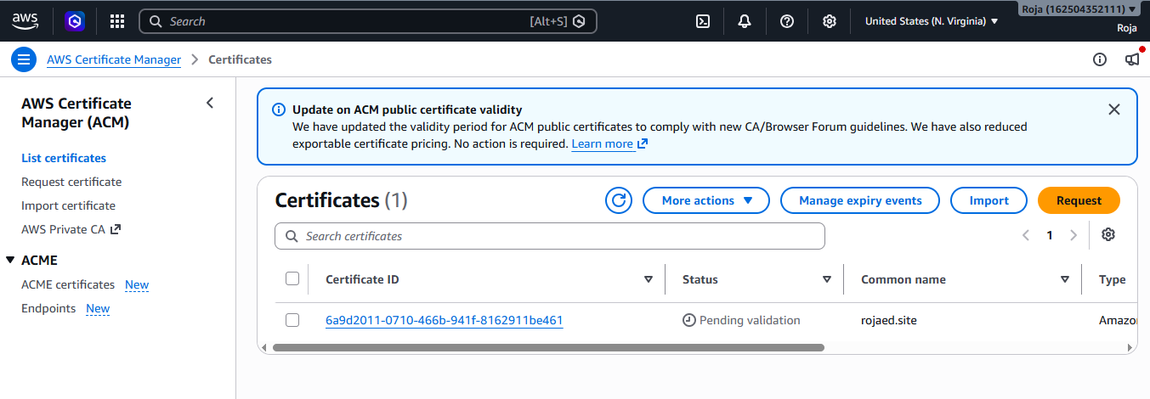

Step 3: Validate certificate:
Wait for 5-10 min and refresh the page, you could see the certificate is issued.
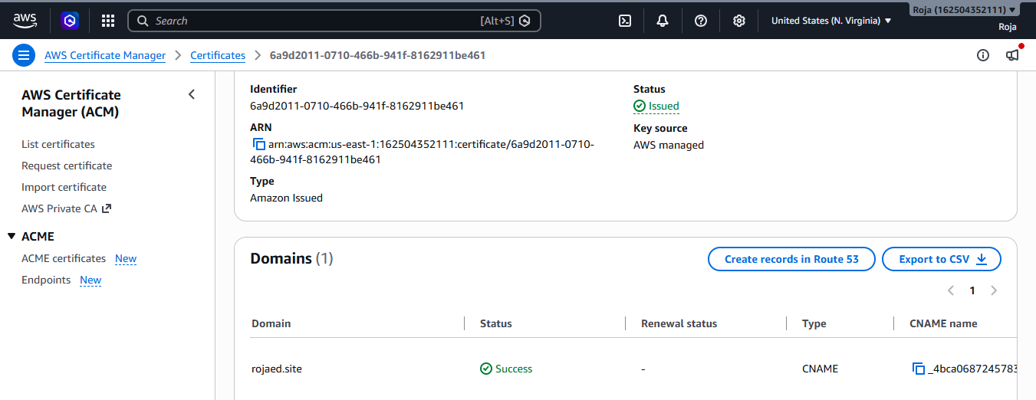
Created cloudfront Distribution: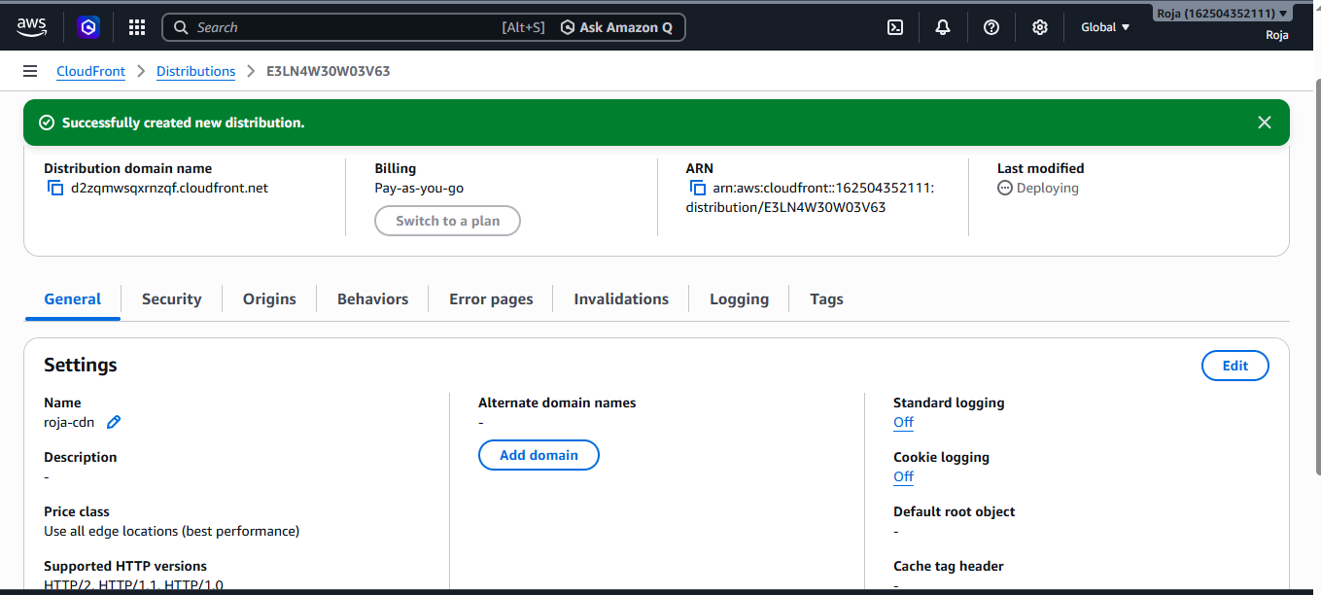
Step 4: Point Route 53 to CloudFront
Record for my domain name is created successfully and created www record

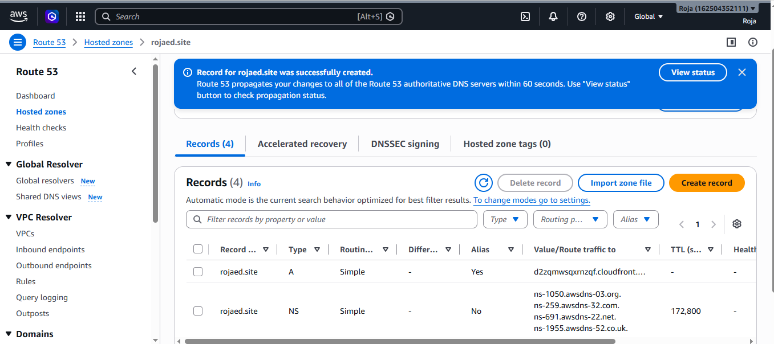
Step 5: Test the Website
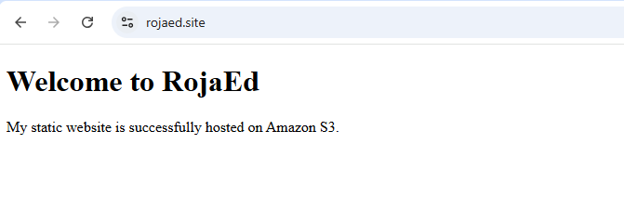Task: 4. Create a Route 53 hosted zone and map the domain with the CDN.

Objective
To create a public hosted zone in Amazon Route 53, update the domain's nameservers, and map the custom domain to an Amazon CloudFront distribution using Alias records.

Prerequisites
- AWS Account
- Registered domain name (for example, rojaed.site)
- Amazon CloudFront distribution already created
- AWS Certificate Manager (ACM) certificate issued
- Domain ownership verified
- Internet connection
Step 1: Open Amazon Route 53
- Search for Route 53.
- Open the Route 53 Dashboard.
- Select Hosted Zones.
- Create a Hosted Zone
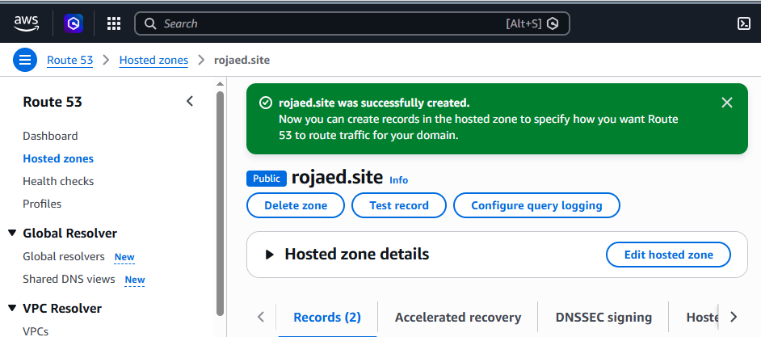

Step 2: Verify the Hosted Zone

After creation, Route 53 automatically creates two records.
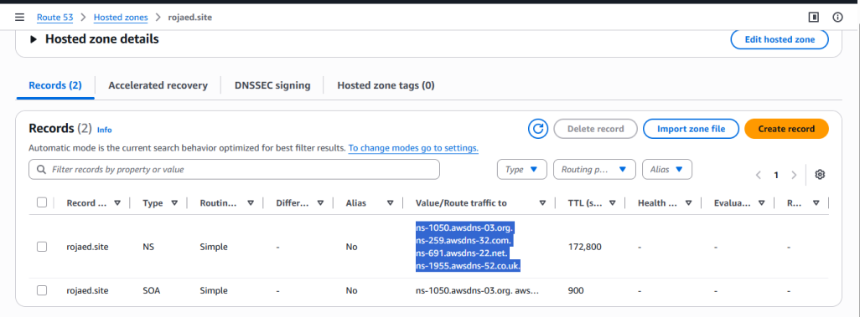
Step 3: Update Name Servers at Domain Registrar

If the domain was purchased from GoDaddy update name servers by replacing GoDaddy nameservers with Route 53 nameservers.

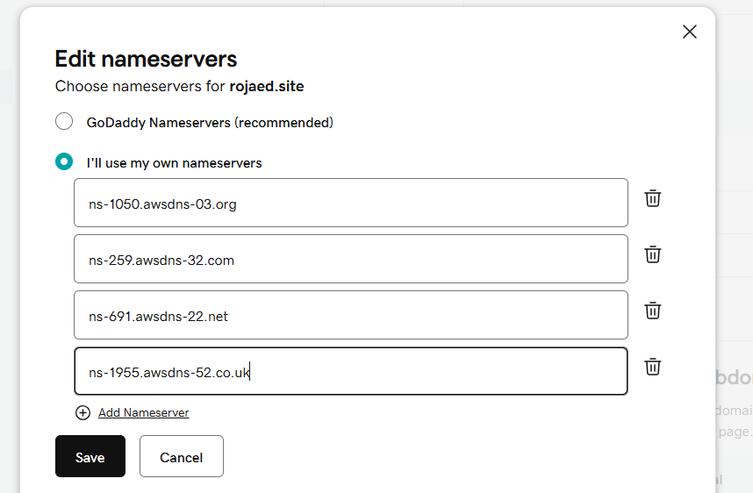

Step 4: Wait for DNS Propagation
It takes few min for DNS propogation
Step 5: Open CloudFront Distribution, Add Custom Domain Name in CloudFront & Attach SSL Certificate

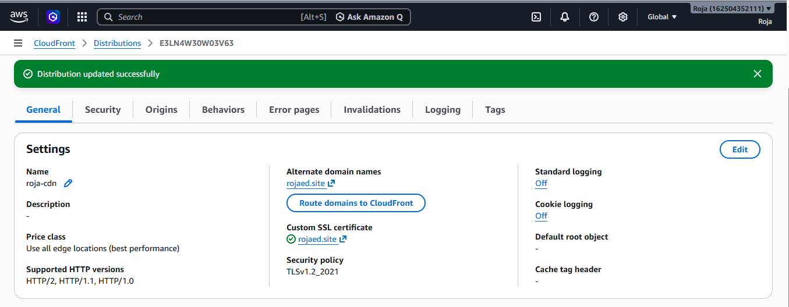
Step 6: Open the Hosted Zone & Create an Alias A Record

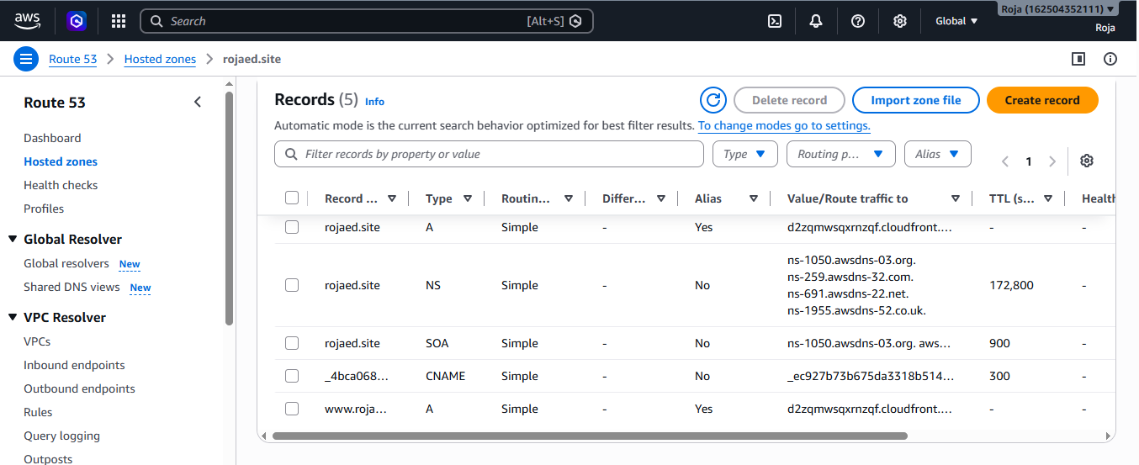
Step 7: Test Website Access
Open browser:
https://rojaed.site



Task: 5. Update the index.html in the S3 bucket and ensure the updated file is accessible using the domain name.

Objective
To update the index.html file stored in an Amazon S3 bucket hosting a static website and ensure that the latest changes are accessible through the configured custom domain name using Amazon CloudFront CDN and Route 53.

Prerequisites
- AWS Account access
- S3 bucket configured for static website hosting
- Existing index.html file
- CloudFront Distribution configured
- Route 53 Hosted Zone configured
- Custom domain mapped to CloudFront
- ACM SSL Certificate attached to CloudFront
Step 1: Prepare Updated index.html File
Open the existing index.html file using a text editor make changes and save it.
Upload Updated index.html to S3 Bucket
Verify File Replacement
Verify S3 Object
- File exists
- Latest modification time is updated
- Object size is changed if content was modified
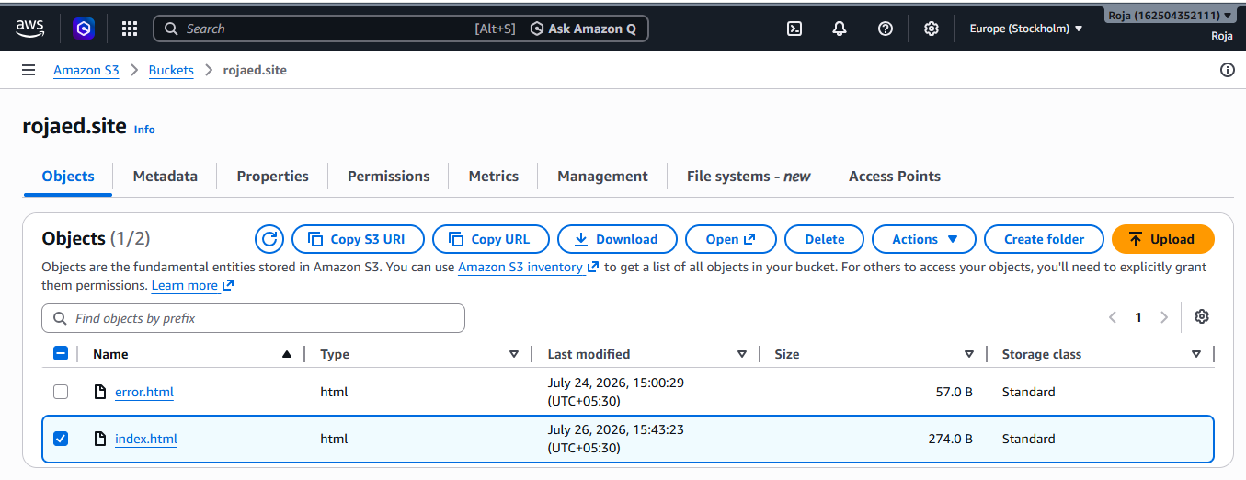
Step 2: Create CloudFront Cache Invalidation
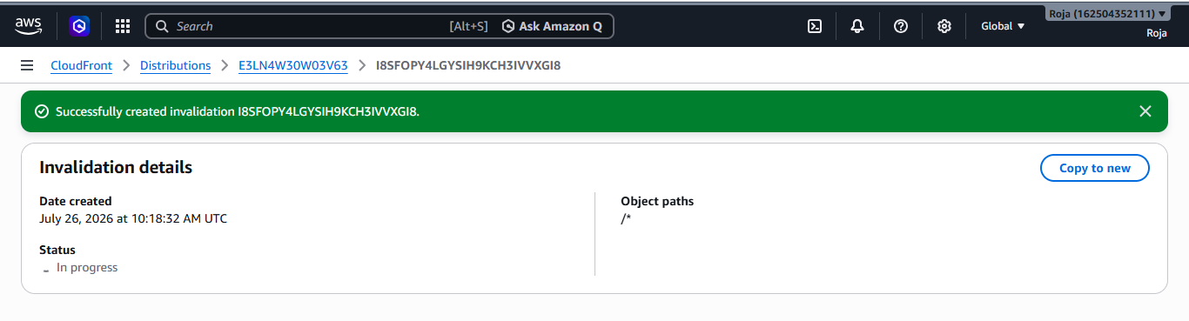
Step 3: Wait for CloudFront Deployment & monitor invalidation status
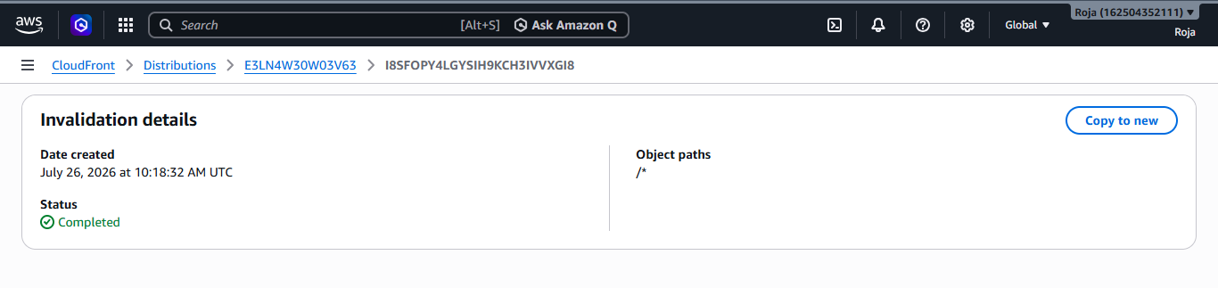
Step 4: Verify Route 53 Domain Mapping
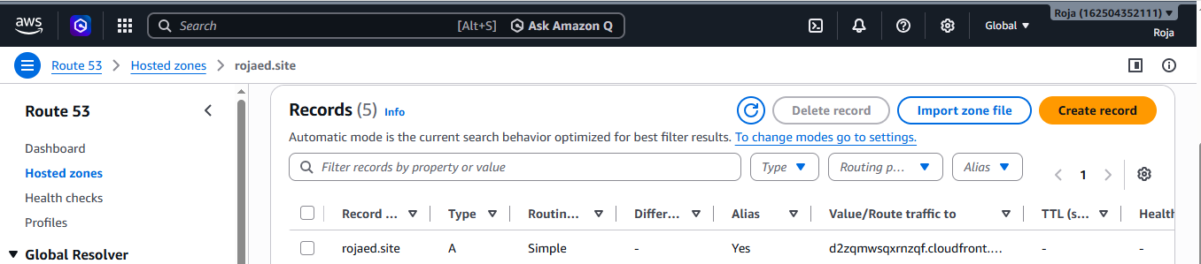

Step 5: Access Updated Website Using Domain Name
https://rojaed.site
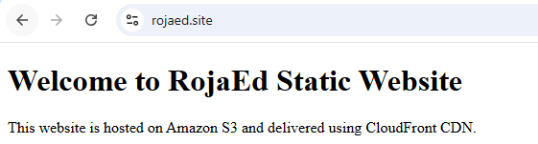

Step 6: Verify CloudFront Response
Right click mouse and select inspect
A window opens at the side or bottom select Network.
When you refresh your website, the Network tab displays every file requested by the browser.

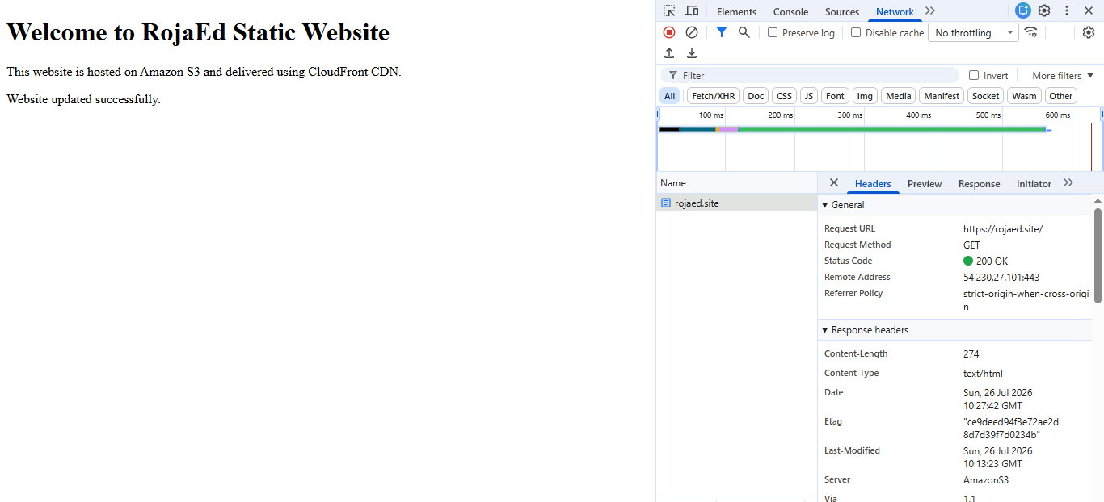

Task: 6.Share the domain name in Slack to test the connectivity.

https://rojaed.site

